Brian Petersen – P.4

-10 – It is impossible for human evolution to have occurred. Although the theory of evolution is appealing, simply can’t believe it because my church leaders have specifically denounced human evolution. This does not mean that I don’t know that humans now evolve; it means that I know that humans did not come into existence through evolutionary means. Also, because of the minute possibility of this, I don’t believe it could have happened.

-5 – It is unlikely for me to prefer my own dogma of that of others. Because of the state I am in, an impressionable and open-minded teenager, I easily consider all views that are given to as equal. Whether I accept that view is dependent upon what I rationalize, but still because of my openness, I am more susceptible to accept view of others who have been around just a little longer than me. I believe there is strength in respecting and considering the opinions of those who have a lot of experience.

7 – I strongly believe that a soul cannot be saved without first being capable of living the law of consecration. If someone is unable to do this, how are they fit for the Kingdom of God? The mental, spiritual, and physical requirements of this higher law are some of the requirements that I believe one person must possess to be worthy of God, I am pretty sure of this, but I do not know with absolute certainty.

4 – Music has the ability to penetrate the conscious mind and influence the subconscious mind quite strongly. Music somehow gets past all the conscious minds filters and is able to suggest things to you without your conscious mind raise any doubts about the lyrics. This is a dangerous thing which is why I believe it to be serious and that we have to be selective of our music choices.

0 – Language is the best form of communication. This may be possible but either way I am indifferent. The main reason is because either way I still can use it to communicate and express my thoughts that I have, and even if we find it is not the best way to communicate, I will still be able to use it as a method of communicating. So it will always be unchanged for me and its possibility does not influence me to one way or another on the spectrum.

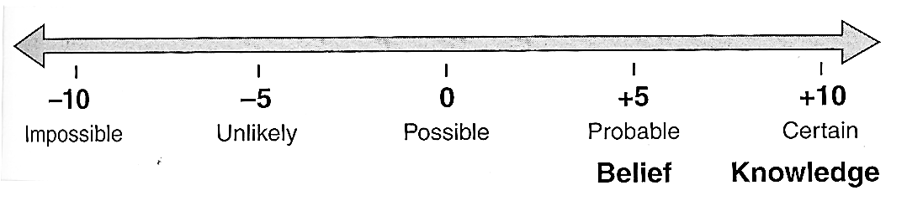

-7 – It seems unlikely that there is too much information in the world for one person to know. I think that everyone is capable of knowing anything that is given to them, but it is the recall that most people struggle with. I believe the challenge for humans is not learning, but rather recalling because humans can remember everything that is given to them. This is of course as far as I have seen, but I still believe its unlikely that there is too much information out there to know and comprehend for humans.

-3 – It is unlikely that communism is a respectable form of government. Because of the studies of the studies and from history, I believe that it has possibility but because of human’s natural pride, it fails to do as promised. Communism in its purest form I believe has some potential for greatness, but it fails because someone wants to take advantage of the system. As well, another reason that I believe that it is unlikely to succeed is because all historical communistic governments were completely destroyed.

2 – I believe it is possible that we have an incomplete understanding of gravity, but I am unsure of how clear that understanding is. Scientists for years have been trying to understand why gravity does things the way it does, but no one has ever been close to understanding why everything attracts each other gravitationally. We are able to predict its events, but we do not even know why it works. This seems to be the paradox of all sciences, we are able to calculate and predict events for a given area, but we do not even understand the fundamentals of that area.

5 – I think that it is probable that science holds a majority of the answers that can help solve temporal problems. By this I mean things of our bodies. An example would be medicine. Because of science, our understanding of the human body has been greatly increased and as a result, we have been able to heal more and more people. As well, all the latest engineering feats have also solved some of the world’s more temporal needed problems. I would like to note that it helps with temporal, not spiritual things.

10 – Procreative powers are to only be thought of using in marital relationships only. This is a key issue that society faces today and it is something that I believe with absolute certainty. I know that these should not be used in any other relationships because I have seen how it can destroy families and relationships if not respected and viewed as sacred. Too many people fall into the trap of not respecting it, and then they suffer the consequences that have come from their actions, but by then it is too late to change your actions.